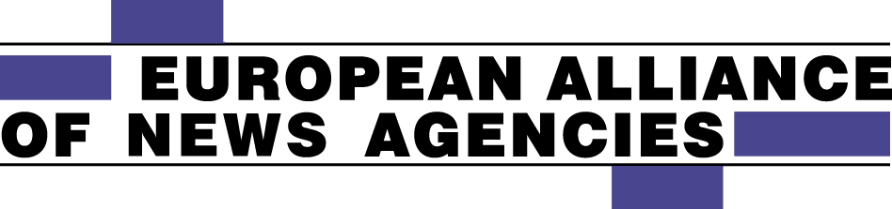

SECRETARIAT
Erik Nylén
Norrtullsgatan 5, 113 29 Stockholm- Sweden
Tel: +46 (0) 8 30 13 24
Mobile: +46 (0)739 86 52 72
E-mail: erik-n@telia.com
Web site: www.newsalliance.org

Statement on copyright by the Board of the European Alliance of News Agencies

March 9, 2017
Aggregators’ and search engines’ unauthorised internet use of media content is threatening citizens’ sustainable access to quality news content and a grave concern especially when discussing how “fake news” and disinformation can distort elections and other democratic processes. The board of the European Alliance of News Agencies (EANA) wants to place on record its concern after reports that the European Parliament’s rapporteur for the proposed copyright directive says the parliament should not approve the EU Commission’s proposed neighbouring rights to protect content creators from unauthorised use of their news stories etc. The EANA board supports the Commission’s proposed extended protection for publishers with the strong amendment that this protection must also include content created by news agencies.
Licensing of content protected by copyright for use is the very basis of the news agency’s business and the main source of funding for those activities. The fees paid for licensed use of this content therefore form the basis of the sustainable, long-term creation of independent, unbiased, trustworthy news content that citizens can rely on to be informed of developments in all areas from politics and economics to sports and current affairs.
Search engines have become data banks, exploiting content they have not created and for which they have paid no remuneration. It is therefore crucial that neighbouring rights be created for news agencies and other publishers, covering all activity in the communication of content to the public.
For the Board of the European Alliance of News Agencies
Jonas Eriksson Erik Nylen
President Secretary General

